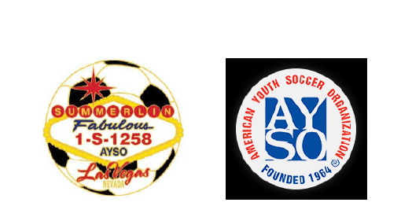

AYSO Region 1258 Board Meeting Minutes

Date: Monday Aug 25th, 2025

Time: 7:00PM

Location: Virtual via Zoom

Attendees will be checked:

|  |  |  |
| --- | --- | --- |
| Kim Wilkinson | Denise Kubajak | Jill Contreras |
| Mindy Veytia | Tim Downing | Andrew Contreras |
| Mike Bauder | Heather Nail | Kennedy Sanchez |
| Mike Schramm | Max Corrick | Andrew Musgrove |

**Topic 1: Motion to approve minutes for 08/18:**

1. Mike Schramm
2. Andrew Contreras

**Topic 2: Denise: Waitlist Numbers-**

|  |  |  |  |
| --- | --- | --- | --- |
| **Division** | **Girls** | **Boys** | **Coed** |
| **6U** | **4** | **0** | **~~~~~~~~~~~~~~~** |
| **8U** | **3** | **14** | **~~~~~~~~~~~~~~~** |
| **10U** | **1** | **4** | **~~~~~~~~~~~~~~~** |
| **12U** | **6** | **5** | **~~~~~~~~~~~~~~~** |
| **14U** | **0** | **4** | **~~~~~~~~~~~~~~~** |
| **18U** | **~~~~~~~~~~~~~~~~** | **~~~~~~~~~~~~~~~~** | **6** |
|  |  |  | **TOTAL: 47** |

**Topic 3:** 6U Division to play on Friday, November 7th to make up for not having a game due to previous Friday being on October 31st.

**Topic 4**: Coach background checks and training compliance reviewed

**Topic 5**: Field layout and scheduling adjustments confirmed

**Topic 6:** Key player losses discussed; replacements and evaluations planned

**Topic 7:** Communication to coaches is essential to avoid surprises at meetings; all must know roster requirements in advance. Some team members were missed during reassignment, causing team imbalance.

**Topic 8**: Equipment distribution scheduled for Saturday; coaches pick up equipment at fields.

Uniform distribution set for September 6, 9–11 AM; uniforms shipped on August 26.

**Topic 9:** Referee coordination process has started after team formation. Referee contacts and surf completions are being organized. Referee training sessions will be scheduled soon. Emails from interested referees and coaches are being received and processed.

**Topic 10:** Coach requested guidance for coaching a 12-year-old girl with autism, ADHD, and developmental delays in her first soccer season. EPIC program and modules on AYSOU suggested as resources for coaching players with developmental disabilities.

**Topic 11:** Picture day to be scheduled; only occurs in fall; attendance encouraged as makeups are limited. Schedule to prioritize younger teams (U6, U8) early; older divisions (U10-U18) later. Coaches requested to donate raffle baskets; flyers to be created for raffle promotion. Coaches prefer picture day scheduling by age group to facilitate post-photo scrimmages.

**Topic 12: Next board meeting Sunday September 7th, 2025 @ 6:00pm via Zoom**